**Beet Seed:**

**1. In Google Docs, create 5 test cases for functional testing of the https://www.carsforsale.com website (5 top priority tests).**

**Functional Testing:**

| **(1) Successfully Search for a Car on Sale** | |
| --- | --- |
| **Preconditions:**   * Tester has WIFI connection in the test device | |
| **Priority:** Critical | |
| **Steps** | **Expected Results** |
| 1. Open <https://www.carsforsale.com/> on a web browser | Homepage opened |
| 2. On the top search bar, enter “BMW” in the “All Makes” field | “All Makes” field entered |
| 3. On the “All Models” field, enter “5 Series (3,780)” | “All Models” field entered |
| 4. On “Min Price” enter “$1,000” and on “Max Price” enter “$75,000” | “Min Price” and “Max Price” are entered |
| 5. Click on “Find Yours” | 3,507 BMW 5 Series results appear |

| **(2) Successfully message the seller of a car by Email** | |
| --- | --- |
| **Preconditions:**   * Tester has WIFI connection in the test device | |
| **Priority:** Critical | |
| **Steps** | **Expected Results** |
| 1. Open <https://www.carsforsale.com/> on a web browser | Homepage opened |
| 2. On the top search bar, enter “BMW” in the “All Makes” field | “All Makes” field entered |
| 3. On the “All Models” field, enter “5 Series (3,780)” | “All Models” field entered |
| 4. On “Min Price” enter “$1,000” and on “Max Price” enter “$75,000” | “Min Price” and “Max Price” are entered |
| 5. Click on “Find Yours” | 3,507 “BMW 5 Series” results appear |
| 6. Click on the first product “2011 BMW 5 Series” | “2011 BMW 5 Series” product page appears |
| 7. On the “Message Seller” form select “Email” | Email option is selected |
| 8. Enter the name field with “SofiaTest” | Name field is entered |
| 9. Enter the last name field with “SofiaTest1” | Last Name field is entered |
| 10. Enter the email address “sofiamouratest7@hotmail.com” | Email address field is entered |
| 11. Enter the Phone “sofiamouratest7@hotmail.com | Phone address is entered |
| 12. On the message field enter “I'm interested and want to know more about the 2011 BMW 5 Series you have listed for $12,495 on Cars For Sale.” | Message field is entered |
| 13. Click on “Send Email” button | “Email has been sent to the seller” |

| **(3) Successfully message the seller of a car by Text** | |
| --- | --- |
| **Preconditions:**   * Tester has WIFI connection in the test device | |
| **Priority:** Critical | |
| **Steps** | **Expected Results** |
| 1. Open <https://www.carsforsale.com/> on a web browser | Homepage opened |
| 2. On the top search bar, enter “BMW” in the “All Makes” field | “All Makes” field entered |
| 3. On the “All Models” field, enter “5 Series (3,780)” | “All Models” field entered |
| 4. On “Min Price” enter “$1,000” and on “Max Price” enter “$75,000” | “Min Price” and “Max Price” are entered |
| 5. Click on “Find Yours” | 3,507 “BMW 5 Series” results appear |
| 6. Click on the first product “2011 BMW 5 Series” | “2011 BMW 5 Series” product page appears |
| 7. On the “Message Seller” form select “Text” | Text option is selected |
| 8. Enter the name field with “SofiaTest” | Name field is entered |
| 9. Enter the last name field with “SofiaTest1” | Last Name field is entered |
| 10. Enter the email address “sofiamouratest7@hotmail.com” | Email address field is entered |
| 11. Enter the Phone “sofiamouratest7@hotmail.com | Phone address is entered |
| 12. On the message field enter “I'm interested and want to know more about the BMW 5 Series you have listed on Cars For Sale.” | Message field is entered |
| 13. Click on “Send Text” button | “Text has been sent to the seller” |

| **(4) Successfully Create an Account** | |
| --- | --- |
| **Preconditions:**   * Tester has WIFI connection in the test device | |
| **Priority:** Critical | |
| **Steps** | **Expected Results** |
| 1. Open <https://www.carsforsale.com/> on a web browser | Homepage opened |
| 2. Click on “Sign In” on the right top of the menu | Drop-down list appears |
| 3. Select the “Individual” option | Pop-up appears |
| 4. Select the option “Don’t have an account? Sign Up” | Sign Up options appear on the menu |
| 5. Select “Sign Up” with email | Required fields to signup appear |
| 6. Enter “First Name” | “First Name” is entered |
| 7. Enter “Last Name” | “Last Name” is entered |
| 8. Enter “Email” | “Email” is entered |
| 10. Enter “Password” | “Password” is entered |
| 11. Click on the button “Sign-up” | Account is created and name is displayed on the top right corner of the page |

| **(5) Successfully find car dealers in 10 miles of a city** | |
| --- | --- |
| **Preconditions:**   * Tester has WIFI connection in the test device | |
| **Priority:** Critical | |
| **Steps** | **Expected Results** |
| 1. Open <https://www.carsforsale.com/> on a web browser | Homepage opened |
| 2. On the menu select the option “Find Car Dealers” | Page to find car dealers appears |
| 3. Select on the “Search Radius” the 10 miles option | 10 miles option is selected |
| 4. Enter the zip code “60007” for the Chicago area | Zip code is entered |
| 5. Click on “Search” | List with car dealers in 10 miles appears |

**2. With** [**https://reqbin.com/**](https://reqbin.com/)**, test the following API** [**Reqres**](https://reqres.in/) **methods:**

* **LIST USERS**
* **SINGLE USER**
* **CREATE**
* **UPDATE (PUT)**
* **UPDATE (PATCH)**
* **DELETE**
* **REGISTER - SUCCESSFUL**
* **LOGIN - SUCCESSFUL**

**Create a document and describe in it the bugs you found. The description can be of any format, but must include screenshots. Add the document to LMS.**

For this exercise, I just compared the response section in <https://reqres.in/> versus the response I got when I ran the API method in <https://reqbin.com/> .

I was not sure if we actually need to create and delete users, with a token, but I didn’t find anything on the website.

* **Bug 1: Method - List Users**

[**https://reqres.in/api/users?page=3**](https://reqres.in/api/users?page=3)

Since there isn’t a page 3, the status for this API should be “404 Not Found”.

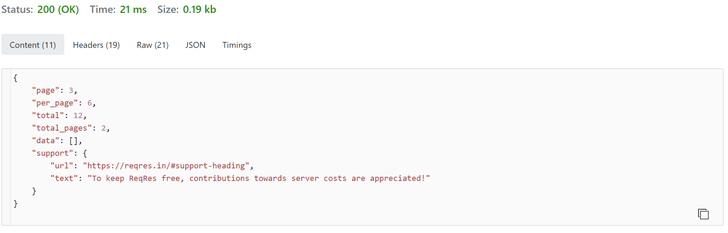

* **Bug 2: Method - Create**

I used the method API <https://reqres.in/api/users> and in content I added:

{

"name": "morpheus",

"job": "leader"

}

In the response I got, the user ID was different from the response in the website (ID was 647 not 747).

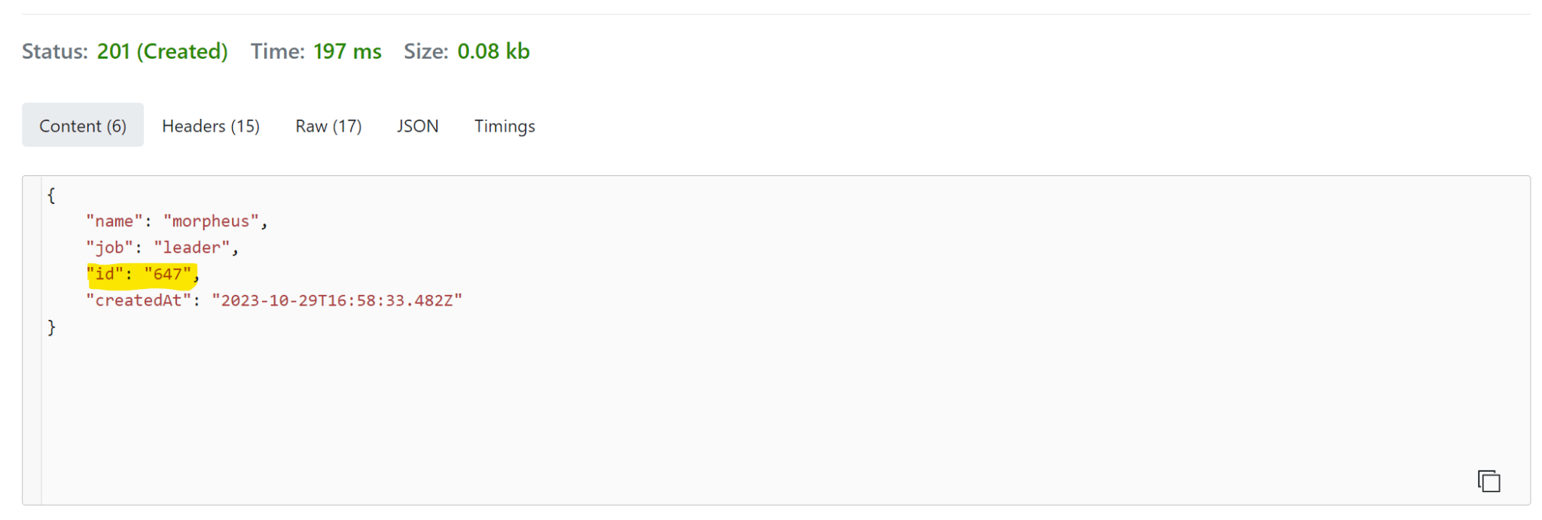

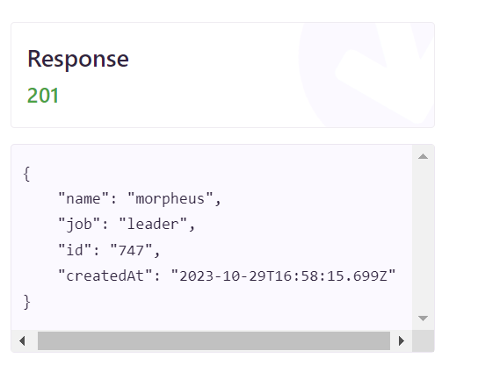

**3. Use** [**https://reqbin.com/**](https://reqbin.com/) **to send one valid request for each method to** [**GO REST**](https://gorest.co.in/) **(/users endpoint).**

**After sending each request, compare its details entered in** [**https://reqbin.com/**](https://reqbin.com/) **and displayed in Developer Tools.**

**Create a document with screenshots showing the correspondence between the data in both tools.**

For some reason, I was noticing the same method in Reqbin and in Developer Tools. I was sending “Put” and “Delete” in Reqbin, but on the Developer Tools I was not seeing the same method.

* **GET:** [**https://gorest.co.in/public/v2/users/628367**](https://gorest.co.in/public/v2/users/628367)

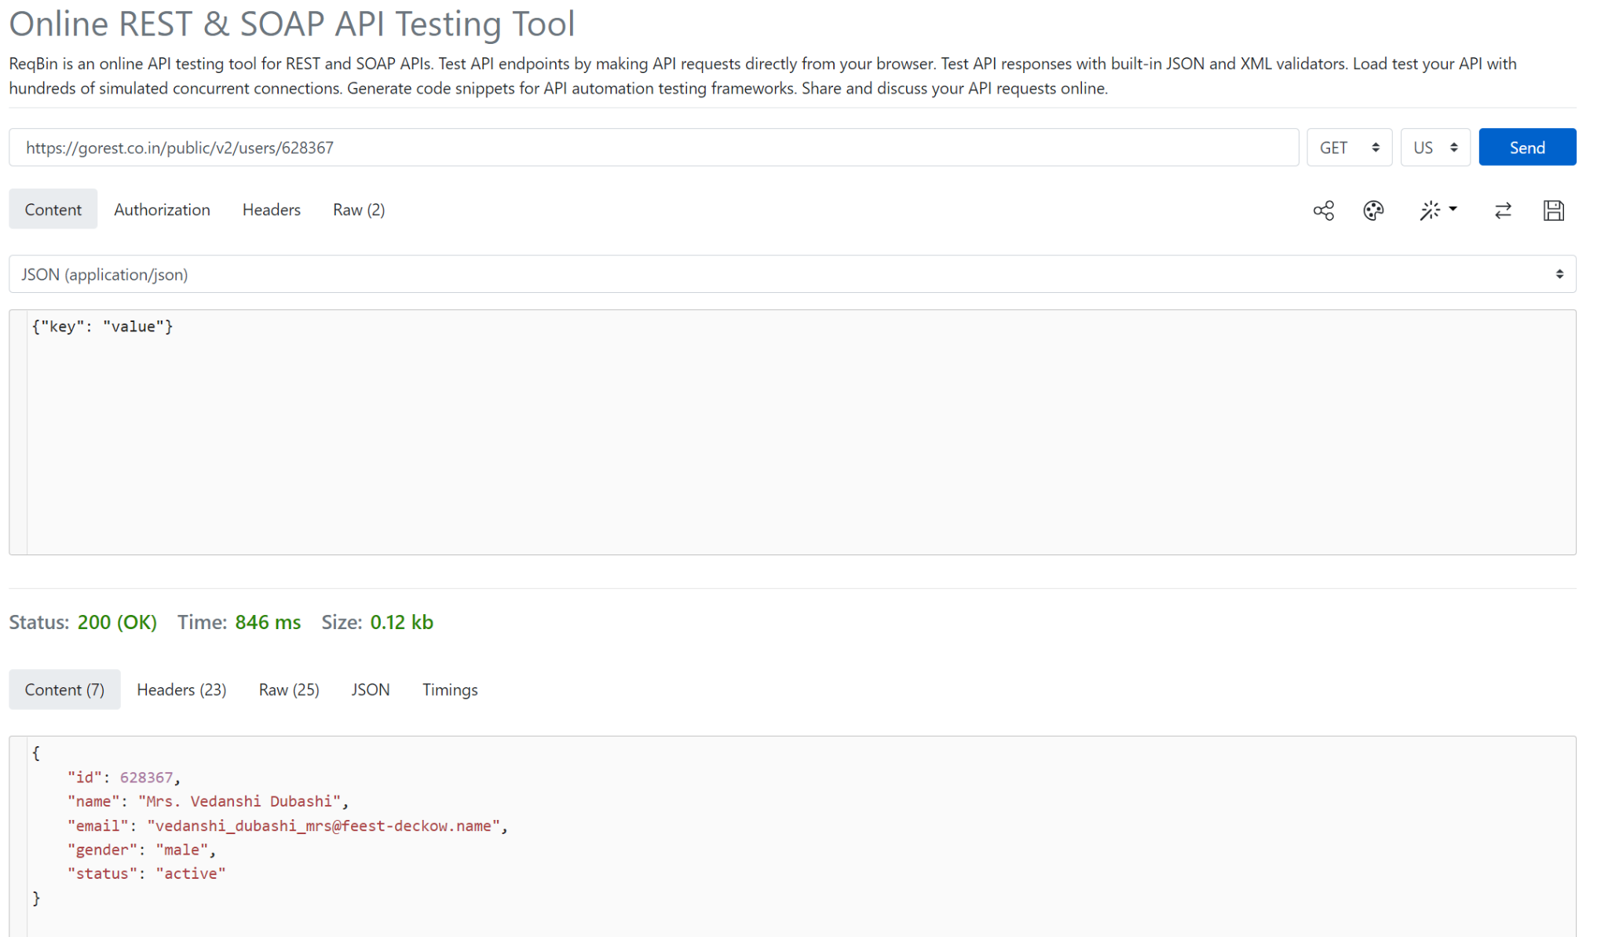

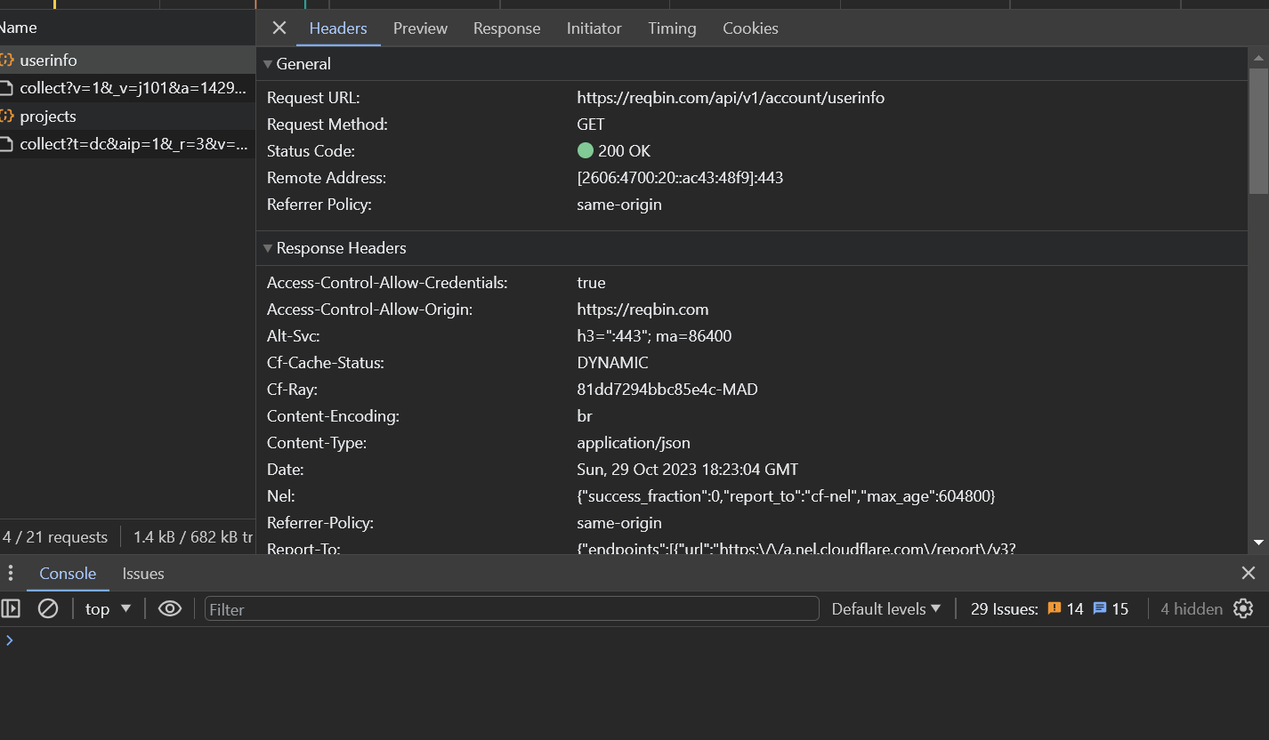

* **POST:** [**https://gorest.co.in/public/v2/users/**](https://gorest.co.in/public/v2/users/)

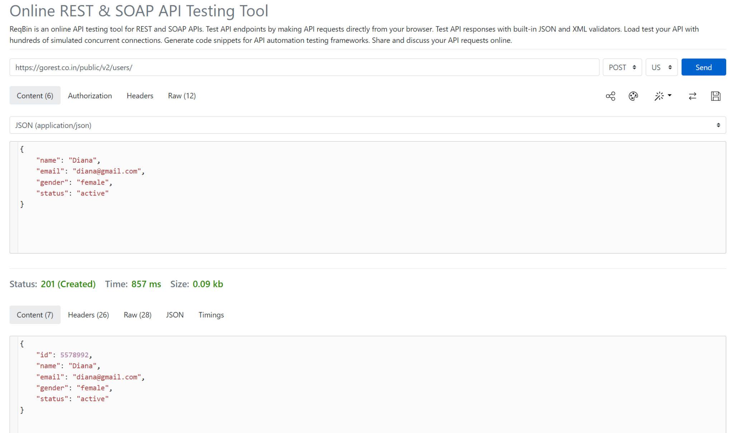

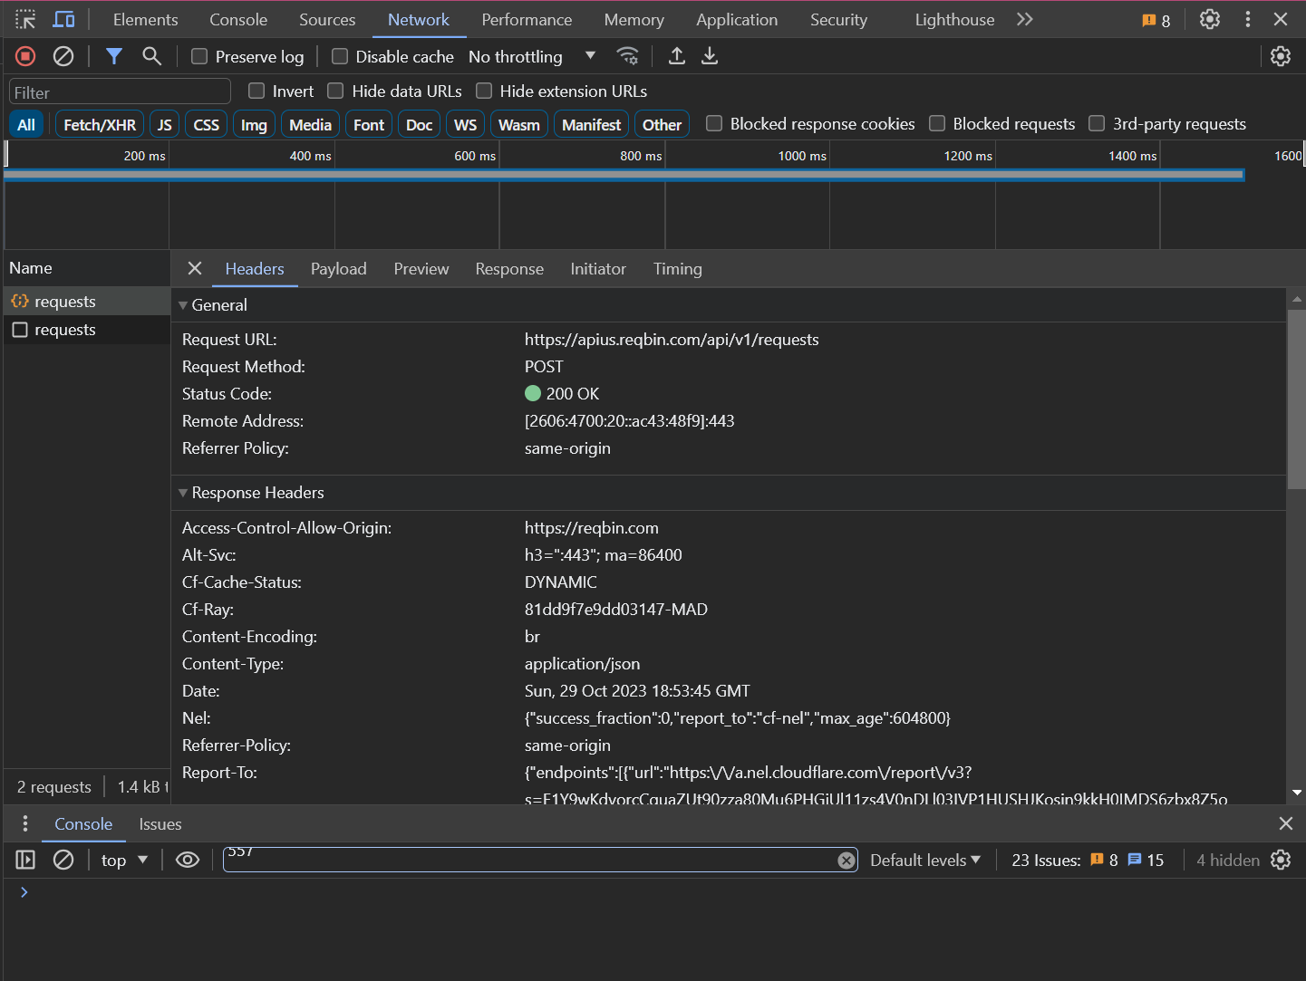

* **PUT|PATCH:** [**https://gorest.co.in/public/v2/users/5578992**](https://gorest.co.in/public/v2/users/5578992)

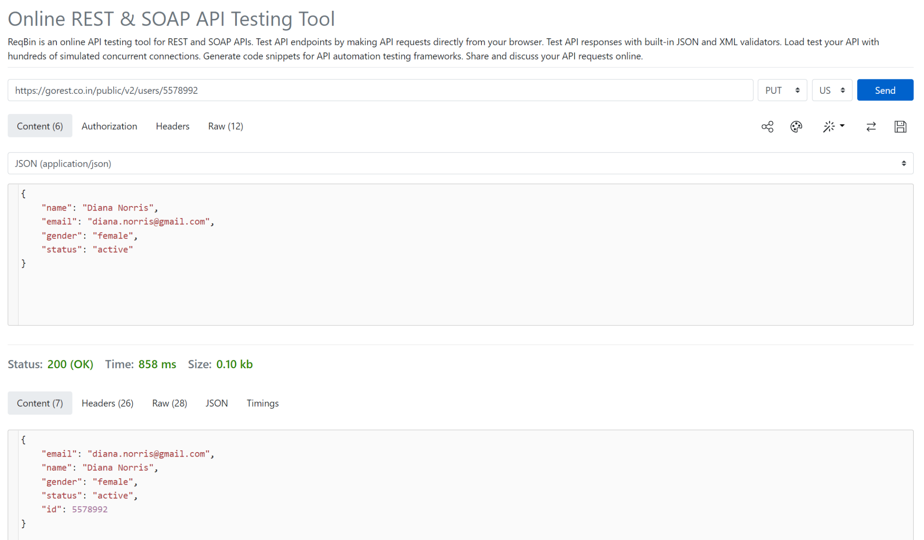

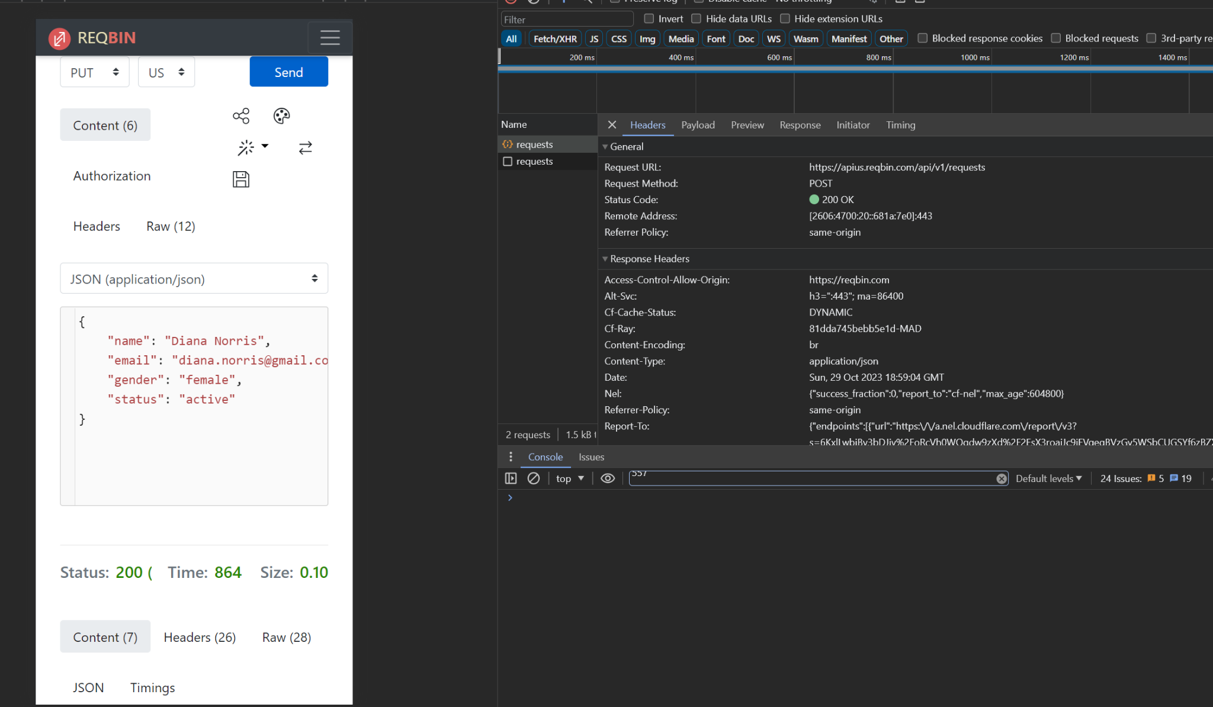

* **DELETE:** [**https://gorest.co.in/public/v2/users/5574430**](https://gorest.co.in/public/v2/users/5574430)

